**ACKNOWLEDGEMENT**

The satisfaction that accompanies the successful completion of any task would be incomplete without mention of the people who made it possible, whose constant guidance and encouragement crowned our effort with appreciation to all those helped us directly or indirectly towards the successful completion of the project.

First, we would like to thank our esteemed college **“Bapuji Institute of Hi-Tech Education"** which has provided us all facilities required.

We thank our beloved Principal **Dr. B. Veerappa** and Vice Principal, **.** **Mr. Siddalingappa K.** for providing an academic environment in the college and thank to Head of the Department **Mr.Bakkesh K. S.** further support which played a major role in reaching our goal.

We are highly grateful to our project guide **Mr.Bakkesh K.S.** for his valuable guidance, support and encouragement throughout the execution of the project.

We are thankful to all the staff members and non-staff members of our college, who have provided instant solutions to our problems and helping us to make this project successful.

The guidance and support received from all our family and friends who contributed became a vital for the success of the project.

**Project Associate**

Aishwarya R G

Pratap D N

Sanjana S L

Sanjay K S

**ABSTRACT**

Farm Tool Outlet Management System is a website created by inculcating CSS, PHP and MYSQL as its front-end and back-end developing tools. This application focuses on providing full details relating to the equipment’s required in farming that is carried out by farmers at their cultivation lands and also to rent those tools.

Here, application modules are admin and farmers where both of them have auto generated user credentials wanted during their login within our application. Thus, our application provides the details of the farming tools and their rental prices per hour as well as per day and also we provide buyer the option of selecting agents if the require.

The data within this application is accurate, safe and secure making this away from the unauthorized user’s access and made user friendly to all and comfortable enough to use it anywhere and anytime

**FARMTOOL-OUTLET MANAGEMENT SYSTEM**

**CONTENT**

1. **Introduction**
2. **Literature Survey**
3. **System Analysis**
4. **Hardware and Software Technology used**
5. **System design**
6. **System implementation**
7. **System testing**
8. **Results and snapshots**
9. **Conclusion and future scope**
10. **Bibliography**

**INTRODUCTION**

**1.INTODUCTION**

**1.1 Aim**

Currently there are many sites that provides information and educate farmers

on use of technology to get maximum produce. It will also enable farmers to rent the best farming tools available in minimum as well as maximum price

Farm-tool outlet management system is a website intended to help farmers to rent the farming tools at better price and to eliminate the brokerage fee.

**1.2 About Project**

In today’s world of digitalization, the internet plays an increasingly important role in everyone’s life, since it has become an integral part of their daily routine. Everyone is being educated about the rapidly evolving technology. The internet is the centre of a massive network that spans the globe, allowing many people to speak with one another or sent data over this vast network in a matter of seconds. Now, the internet has entered the sector of agriculture, where farmers can rent the farming tools with the help of internet.

Farm Tool Outlet Management System indicates the intelligent & easier renting of farming tools . This site helps the farmers to rent farming tools & provides a larger options & helping them to not restrict themselves to local market.

The website consist of two modules namely

1. Administrator
2. Customer

The administrators of our website are supervisor, administrator have the authority to view the product details and also view the farmers details/

The customers can rent the product they want through online using website, the customer create an account on the site , and login by using unique username and password.

**LITERATURE SURVEY**

**2.LITERATURE SURVEY**

**2.1 Existing system**

There are some web applications are available in the internet for selling and buying farmers product in the best price, but our website is convenient to use in a simple way. Data collection plays an important role in a projects succession and also it plays an inevitable role on the timely completion of project. The data in the project includes contact information of customers, farmers and their farming tools details which is stored in a database. To assure safety only the admin has proper accesses to the information provided by the clients.

**2.2 Proposed system**

we create a website for monitoring farming tools through internet the main aim of this site is to reduce the manual work of people , in this website all details and records are maintained in the database software farm tools names & its prices are displayed in the website whenever we need data we can access the database to retrieve the data that already stored at anywhere in the world the prices will be updated by admins. The records are frequently updated by the users the working methods of the users are designed by every simple method.

**2.3 Technologies Used**

**Hyper Text Markup Language**

HTML documents are plain-text (also known as ASCCII) files that can be created using any text editor. You can also use word processing software if you remember to save your document as “text only with line breaks”.

**CSS**

Cascading Style Sheet is a style sheet language used for describing the presentation semantics (the look and formatting) of a document written in a markup language. CSS is designed primarily to enable the separation of document content (written in HTML or a similar markup language) from document presentation, including elements such as the layout, colours, and fonts. CSS can also allow the same markup paste the presented in different styles for different rendering methods.

**PHP**

Hypertext Pre-Processor is a general-purpose scripting language geared toward web development. It was originally created by Danish-Canadian programmer Rasmus Lerdorf in 1993 and released in 1995. The PHP reference implementation is now produced by PHP group. PHP code is usually processed on a web server by a PHP interpreter implementation as a module, a daemon or as a common gateway interface (CGI) executable.

**XAMPP**

XAMPP is a free and open-source cross-platform web server solution start package developed by Apache friend, consisting mainly of the Apache HTTP server, MariaDB database, and interpreters for scripts written in the PHP and Perl programming language. Since most actual web server deployments use the same components as XAMPP, it makes transitioning from a local test server to a live server possible.

**JavaScript**

JavaScript is a programming language that is one of the core technologies the world wide web, alongside HTML and CSS. The JS is text-based and can be used on both client and server-side. It controls multimedia within web pages and allows them to become interactive. JavaScript empowers a developer to do many things like adding animation to images or updating content automatically on a page. JavaScript is what allows you to interact with the vast majority of web pages that you visit.

**MY SQL**

MYSQL cluster enables users to meet the database challenges of next generation web, A relational database organizes data into one or more data tables in which data may be related to each other; these relations help structure the data. SQL is a language programmers use to create, modify and extract data from the relational database, as well as control user access to the database. In addition to relational databases and SQL, an RDBMS like MySQL works with an operating system to implement a relational database in a computer's storage system, manages users, allows for network access and facilitates testing database integrity and creation of backups.

**HARDWARE AND SOFTWARE TECHNOLOGY USED**

**4.Hardware and Software Requirements**

**4.1 Minimum Hardware Requirements**

* Processor - 11th Gen Intel(R) Core(TM) i3 or higher.
* RAM - 2GB or more.
* Keyboard - Any Key Board with minimum required keys.
* Mouse - Any mouse.

**4.2 Minimum Software Requirements**

* Operating system - Windows 10 or higher.
* Front End - HTML, CSS, JS, PHP
* Back End - MYSQL.
* Browser - Google chrome, Firefox.
* Web server - XAMPP server.

**SOFTWARE REQUIREMENT SPECIFICATION**

**4.SOFTWARE REQUIREMENT SPECIFICATION**

**4.1 Introduction**

In India agriculture is crucial part. Agriculture is only one income resource for most of the Indian, as per census in 2011 in India, approximately 118 million people are farmers and 144 billion people are laborers working in an agricultural field. Total Indian papulation of Indian in 2011 was nearly about 121 crore and out of which nearly about 2630 lack people are farmers. All necessary data is available on the internet and so of agriculture too.

Indian farmers are lagging behind in the use of technologies and new advancement. The huge amount of data available over the web. India is second largest producer of agriculture product, but Indian farmer are poor and people are facing crisis to rent farming tools . The system aims to accomplish the farmers need and to make them fully independent in financial sector. Today mobile phones are available to every individual farmer can search the marketing rates of farm tools they can easily solve their problem with just one fingertip on their phones screen with the help of our website they can directly contact the customers and other farmers to get some suggestions. In this paper we are describing a project which is a web-based website that will help farmers that they would get information about updated rates of farm tools rent , the customers can rent farm tools from the farmers for their sake of business to home and many more.Mainly they will get a good platform for selling their farm tools with best price this application will helps to increase the profit for the farmers and the respective customers.

**4.2 Purpose**

This Document includes software requirements for the “Farm tool Outlet Management System ” Project. The purpose of this project is to detail the requirements for all the functionality in farm tool outlet management system. This portal is mean to serve as a guide to the developers and users. The purpose of the requirement document is to specify and provide all the information required to design, develop and test the system this document ensures that the person reading the document understands what they are looking for.

**4.3 Scope**

The products information portal was designed to provide greater support to farmers and customers. farmers can use this website to add information about their available farming tools. Customers can use the program to acquire all of the information they need about the farming tools. Customers can rent required farm tools here, and farmers or admins can see what the customers have rented. Both customer and farmer will benefit from this website.

**4.4 Functional and Non-Functional Requirements**

**Admin**

* Admin can login to the application.
* Admin can view the farm tool list.
* Admin can view the farmers details.
* Admin can view the customer details.
* Admin can view the rental list.
* Admin as full privilege of the website.

**Farmer**

* Farmers can register to the website.
* Farmer can login to the website.
* Farmer can add, view and delete the farm tool list.
* Farmers can view the rental list.

**Customer**

* Customer can register to the website.
* Customer can login to the website.
* Customer can view the available farm tool and price.
* Customer can booking the farm tool.

**Non-Functional Requirements**

**Robustness:**

It’s vital that the system should be a fault tolerant with the respect to illegal user input. Error checking must be built in the system to prevent system failure.

**Correctness:**

Since this project is used to provide the actual and correct information about details of the particular project which were done by students. The admin will have more privileges on the database; this system should always provide correct response and the data in all the database should always be constantly updated with the latest information.

**Reliability:**

The system has to provide the correct information under any situation, in case of any error in input or operation, system should reflect proper message or give proper helping information.

**Maintainability:**

The project will be used for a long time, it must be easy to maintain and easy to incorporate future changes. The design if the system should be a module based and changing the design of the one module should not affect the proper operation of the module.

**Portability:**

The system should be portable so as to can run in any web browser with very little or no modifications.

**Security:**

All security precautions are taken to make the product more reliable, only valid i.e. registered persons can access it.

**SYSTEM DESIGN**

**5. SYSTEM DESIGN**

**5.1 Modules**

This project has following modules.

* **Admin:**

Our application’s admin is a power user. By default, the admin role is created. The major responsibility of the admin is to add the farm tool categories. Admin has the option to view and delete the farmers, and also can approve or delete customers, and also can approve or delete the farmers here. He can also view and delete the orders from the users along with the farm tool.

* **Farmer:**

Farmers should register on the website by providing all of their current information. Farmers can login using their own username and password. The farm tool information is added by the farmers. He has access to the customers’ orders for their farm tool. The complete process of orders also can be done by the farmers itself.

**5.2 Use case diagram**

**Use case diagram for admins.**

**REGISTRATION**

**LOGIN**

**ADD PRODUCT**

**ADMIN**

**VIEW DETAILS**

**CATEGORY LIST**

**Use case diagram for customer or farmers.**

**REGISTRATION**

**LOGIN**

**VIEW PRODUCT**

**CUSTOMER**

**RENTAL DETAILS**

**CANCLE PRODUCT**

**5.3 Data Flow Diagram**

A data flow diagram is a graphical representation of the flow of data Through an information model. A data flow diagram can also be used for the visualization of data processing.

**Customer**

**Admin**

**Farm tool outlet management system**

**DATABASE**

**Admin DFD**

Registration

Admin

Customers

Manage

Farm tools

Update

Products

Process

Orders

**Customer DFD**

View

customer

Login

Farm Tools

Farm Tools

**5.4 Data base table**

**1.Category Table:**

|  |  |
| --- | --- |
| Column Name | Data Type |
| Id | **int** |
| Category | **Varchar (100)** |

**2.Login Table:**

|  |  |
| --- | --- |
| Column Name | Data Type |
| User Id | **Varchar (20)** |
| Password | **Varchar (20)** |
| User Type | **Varchar (20)** |

**3.Customer Table:**

|  |  |
| --- | --- |
| Column Name | Data Type |
| Id | **Varchar (20)** |
| Password | **Varchar (100)** |
| Farmer | **Varchar (100)** |
| Addressline1 | **Varchar (100)** |
| Addressline2 | **Varchar (100)** |
| City | **Varchar (100)** |
| Mobile | **Varchar (20)** |
| E-mail ID | **Varchar (100)** |

|  |  |
| --- | --- |
| Column Name | Data Type |
| Id | **Varchar (20)** |
| Product | **Varchar (100)** |
| Category | **Varchar (100)** |
| Product Details | **Varchar (500)** |
| Price | **Int** |
| Image | **Varchar (200)** |
| Status | **Varchar (50)** |
| Customer ID | **Varchar (20)** |

**4.Farm tools Table**

**5. Order Table:**

|  |  |
| --- | --- |
| Column Name | Data Type |
| ID | **Varchar (20)** |
| Order Date | **Date** |
| Product | **Varchar (100)** |
| Price | **Int** |
| Qty | **Int** |
| Total Amount | **Int** |
| Farmer ID | **Varchar (20)** |
| Status | **Varchar(50)** |
| Customer ID | **Varchar(20)** |

**SYSTEM IMPLEMENTATION**

**6. SYSTEM IMPLEMENTATION**

The process of putting the development system to actual use is called system implementation. It includes all activities that place to use the new system. Once the planning has been completed, the major effort in the department is to ensure that the programs in the system are working properly. The system implementation phase follows the test phase.

The implementation phase of software development involves translation of design specification into source code by using required platform and other tools. The entire software is implemented using HTML and databases SQL server connection.

In the implementation phase, the project reaches its finishing stage. After the development phase of the SDLC (System development life cycle) is complete, the system is implemented. The software, which was designed in design phase and programmed in development phase of the SDLC, was installed on PC’s that required it. The person making use of it is trained during the phase of the SDLC. Moreover, both the hardware and software are tested. The problems that we were unable to simulate were solved by the users. These were the main activities performed by us in the course of the project, which lead to its proper completion.

**6.1 Admin Login**

<?php

include('login_client.php'); // Includes Login Script

if(isset($_SESSION['login_client'])){

header("location: index.php"); //Redirecting

}

?>

<!DOCTYPE html>

<html>

<head>

<title> Admin Login | Farm Equipment Rentals </title>

<link rel="stylesheet" href="https://fonts.googleapis.com/css?family=Lato">

<link rel="stylesheet" href="assets/bootstrap/css/bootstrap.min.css">

<link rel="stylesheet" href="assets/fonts/font-awesome.min.css">

<link rel="stylesheet" href="assets/w3css/w3.css">

<script type="text/javascript" src="assets/js/jquery.min.js"></script>

<script type="text/javascript" src="assets/js/bootstrap.min.js"></script>

<link rel="stylesheet" href="assets/css/clientlogin.css">

</head>

<body>

<!-- Navigation -->

<nav class="navbar navbar-custom navbar-fixed-top" role="navigation" style="color: black">

<div class="container">

<div class="navbar-header">

<button type="button" class="navbar-toggle" data-toggle="collapse" data-target=".navbar-main-collapse">

<i class="fa fa-bars"></i>

</button>

<a class="navbar-brand page-scroll" href="index.php">

Farm Equipment Rentals </a>

</div>

<!-- Collect the nav links, forms, and other content for toggling -->

<?php

if(isset($_SESSION['login_client'])){

?>

<div class="collapse navbar-collapse navbar-right navbar-main-collapse">

<ul class="nav navbar-nav">

<li>

<a href="index.php">Home</a>

</li>

<li>

<a href="#"><span class="glyphicon glyphicon-user"></span> Welcome <?php echo $_SESSION['login_client']; ?></a>

</li>

<li>

<ul class="nav navbar-nav navbar-right">

<li><a href="#" class="dropdown-toggle active" data-toggle="dropdown" role="button" aria-haspopup="true" aria-expanded="false"><span class="glyphicon glyphicon-user"></span> Control Panel <span class="caret"></span> </a>

<ul class="dropdown-menu">

<li> <a href="entertool.php">Add Tool</a></li>

<li> <a href="enteragent.php"> Add Agent</a></li>

<li> <a href="clientview.php">View</a></li>

</ul>

</li>

</ul>

</li>

<li>

<a href="logout.php"><span class="glyphicon glyphicon-log-out"></span> Logout</a>

</li>

</ul>

</div>

<?php

}

else if (isset($_SESSION['login_customer'])){

?>

<div class="collapse navbar-collapse navbar-right navbar-main-collapse">

<ul class="nav navbar-nav">

<li>

<a href="index.php">Home</a>

</li>

<li>

<a href="#"><span class="glyphicon glyphicon-user"></span> Welcome <?php echo $_SESSION['login_customer']; ?></a>

</li>

<li>

<a href="#">History</a>

</li>

<li>

<a href="logout.php"><span class="glyphicon glyphicon-log-out"></span> Logout</a>

</li>

</ul>

</div>

<?php

}

else {

?>

<div class="collapse navbar-collapse navbar-right navbar-main-collapse">

<ul class="nav navbar-nav">

<li>

<a href="index.php">Home</a>

</li>

<li>

<a href="clientlogin.php">Admin</a>

</li>

<li>

<a href="customerlogin.php">Customer</a>

<div class="container">

<div class="navbar-header">

<button type="button" class="navbar-toggle" data-toggle="collapse" data-target=".navbar-main-collapse">

<i class="fa fa-bars"></i>

</button>

<a class="navbar-brand page-scroll" href="index.php">

Farm Equipment Rentals </a>

</div>

<!-- Collect the nav links, forms, and other content for toggling -->

<?php

if(isset($_SESSION['login_client'])){

?>

<div class="collapse navbar-collapse navbar-right navbar-main-collapse">

<ul class="nav navbar-nav">

<li>

<a href="index.php">Home</a>

</li>

<li>

<a href="#"><span class="glyphicon glyphicon-user"></span> Welcome <?php echo $_SESSION['login_client']; ?></a>

</li>

<li>

<ul class="nav navbar-nav navbar-right">

<li><a href="#" class="dropdown-toggle active" data-toggle="dropdown" role="button" aria-haspopup="true" aria-expanded="false"><span class="glyphicon glyphicon-user"></span> Control Panel <span class="caret"></span> </a>

<ul class="dropdown-menu">

<li> <a href="entertool.php">Add Tool</a></li>

<li> <a href="enteragent.php"> Add Agent</a></li>

<li> <a href="clientview.php">View</a></li>

</ul>

</li>

</ul>

</li>

<li>

<a href="logout.php"><span class="glyphicon glyphicon-log-out"></span> Logout</a>

</li>

</ul>

</div>

<?php

}

else if (isset($_SESSION['login_customer'])){

?>

<div class="collapse navbar-collapse navbar-right navbar-main-collapse">

<ul class="nav navbar-nav">

<li>

<a href="index.php">Home</a>

</li>

<li>

<a href="#"><span class="glyphicon glyphicon-user"></span> Welcome <?php echo $_SESSION['login_customer']; ?></a>

</li>

<li>

<a href="#">History</a>

</li>

<li>

<a href="logout.php"><span class="glyphicon glyphicon-log-out"></span> Logout</a>

</li>

</ul>

</div>

<?php

}

else {

?>

<div class="collapse navbar-collapse navbar-right navbar-main-collapse">

<ul class="nav navbar-nav">

<li>

<a href="index.php">Home</a>

</li>

<li>

<a href="clientlogin.php">Admin</a>

</li>

<li>

<a href="customerlogin.php">Customer</a>

<label style="margin-left: 5px;color: red;"><span> <?php echo $error; ?> </span></label>

<div class="panel panel-primary">

<div class="panel-heading"> Login </div>

<div class="panel-body">

<form action="" method="POST">

<div class="row">

<div class="form-group col-xs-12">

<label for="customer_username"><span class="text-danger" style="margin-right: 5px;">*</span> Username: </label>

<div class="input-group">

<input class="form-control" id="customer_username" type="text" name="customer_username" placeholder="Username" required="" autofocus="">

<span class="input-group-btn">

<label class="btn btn-primary"><span class="glyphicon glyphicon-user" aria-hidden="true"></label>

</span>

</span>

</div>

</div>

</div>

<div class="row">

<div class="form-group col-xs-12">

<label for="customer_password">

<span class="text-danger" style="margin-right: 5px;">*</span> Password:

</label>

<div class="input-group">

<input class="form-control" id="customer_password" type="password" name="customer_password" placeholder="Password" required="">

<span class="input-group-btn">

<label class="btn btn-primary"><span class="glyphicon glyphicon-lock" aria-hidden="true"></span></label>

</span>

</div>

</div>

</div>

<div class="row">

<div class="form-group col-xs-4">

<button class="btn btn-primary" name="submit" type="submit" value=" Login ">Submit</button>

</div>

</div>

<label style="margin-left: 5px;">or</label> <br>

<label style="margin-left: 5px;"><a href="customersignup.php">Create a new account.</a></label>

</div>

</div>

</div>

</div>

</body>

<footer class="site-footer">

<div class="container">

</div>

</div>

</footer>

**SYSTEM TESTING**

**7. TESTING**

System should not be tested as a single, monolithic unit. The testing process should therefore proceed in stages where testing is carried out incrementally in conjunction with system implementation. Errors in program components may come to light at a later stage of the testing process. The process is therefore an iterative one with information being fed back from later stages to earlier parts of the process. The various strategies that were used in testing this software were as follows:

1. Unit Testing

2. Integration Testing

3. System Testing

* Validation Testing
* Black Box Testing
* White Box Testing

4. Acceptance Testing

Unit testing

Module Testing

Subsystem Testing

System Testing

Acceptance Testing

**7.1 Test Cases and Results**

**Login Page**

|  |  |  |
| --- | --- | --- |
| **Input** | **Expected result** | **Actual result** |
| Click on login button without  entering username and password. | User-friendly error message should be displayed to user. | Respective error messages are displayed to users**.** |
| Click on login button with entering invalid username and password**.** | Error message should be displayed**.** | User-friendly error message is displayed. |
| Click on login button by providing valid username and password**.** | User should be login into our website. | User is logged into our website. |

**RESULTS AND SNAPSHOTS**

**8.SNAPSHOTS**

**Home Page**

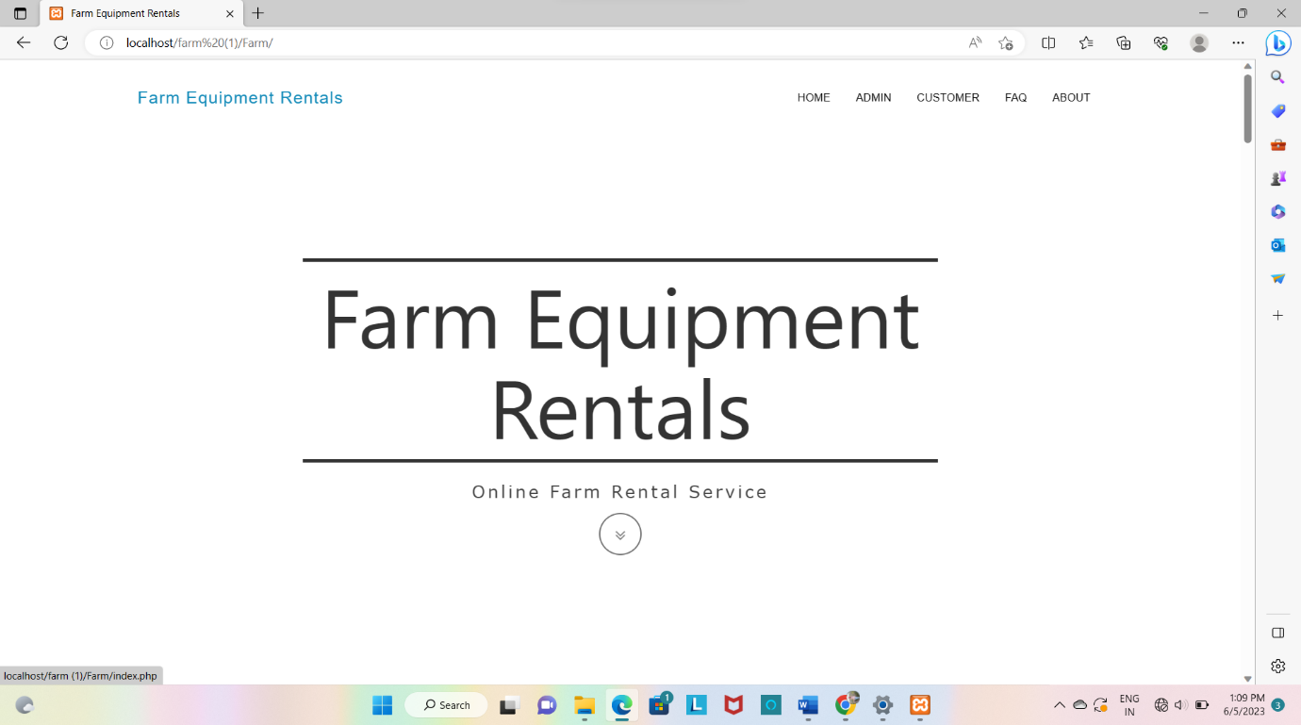

**Admin Login**

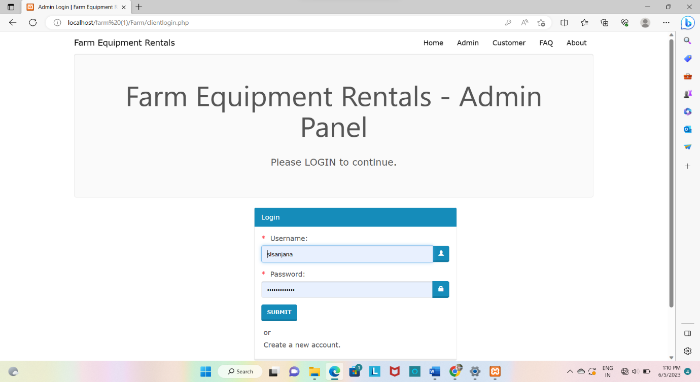

**Control panel on admin side**

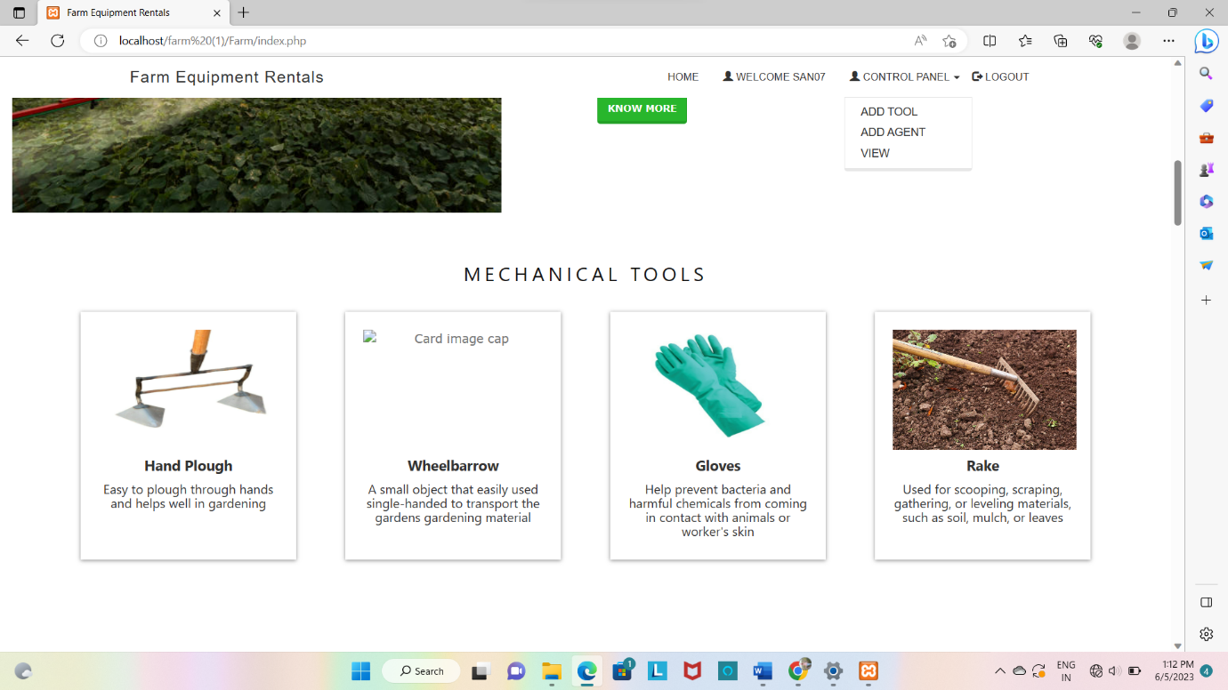

**Adding tools on admin side**

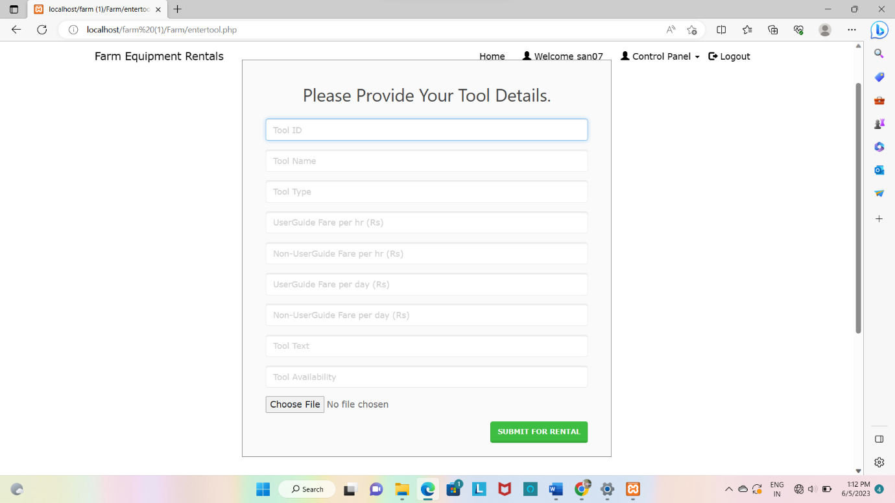

**Adding agents on admin side**

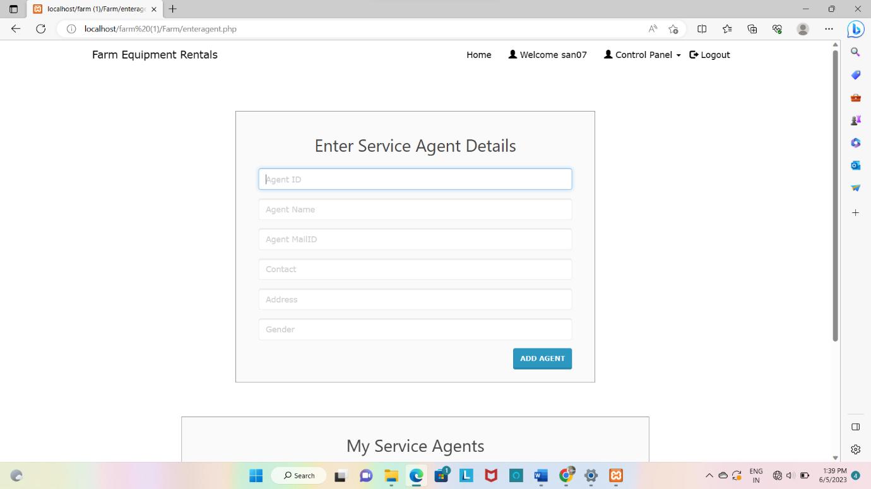

**Customer Login**

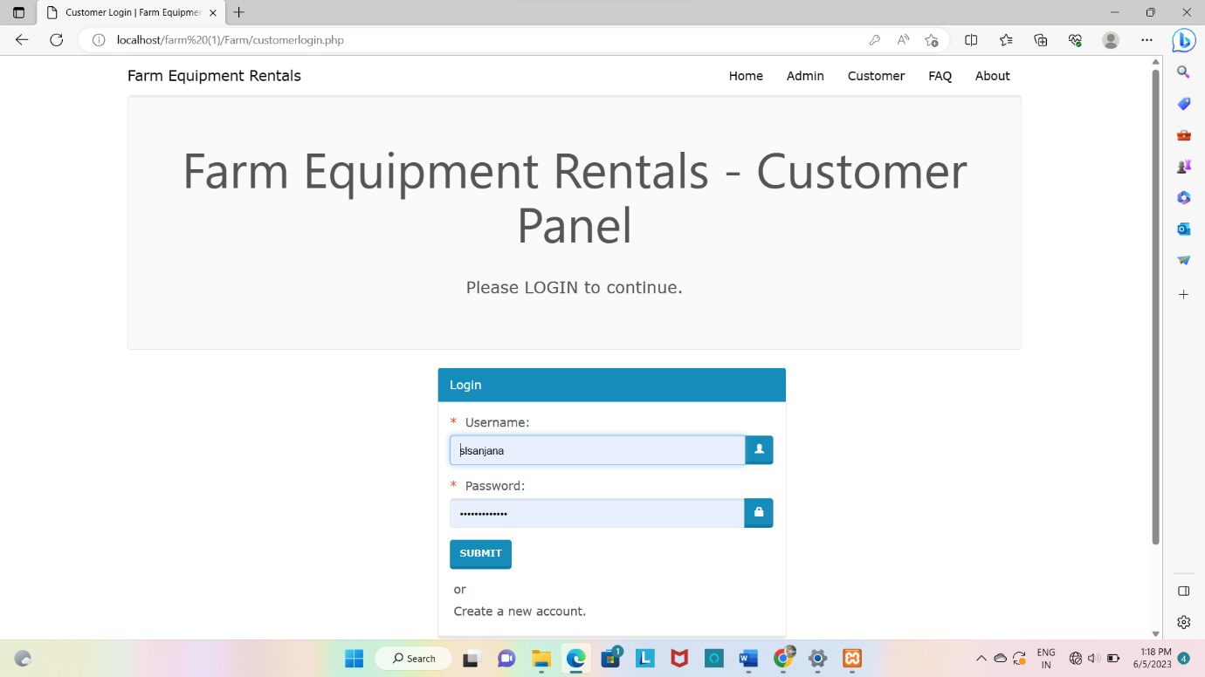

**Control panel on customer side**

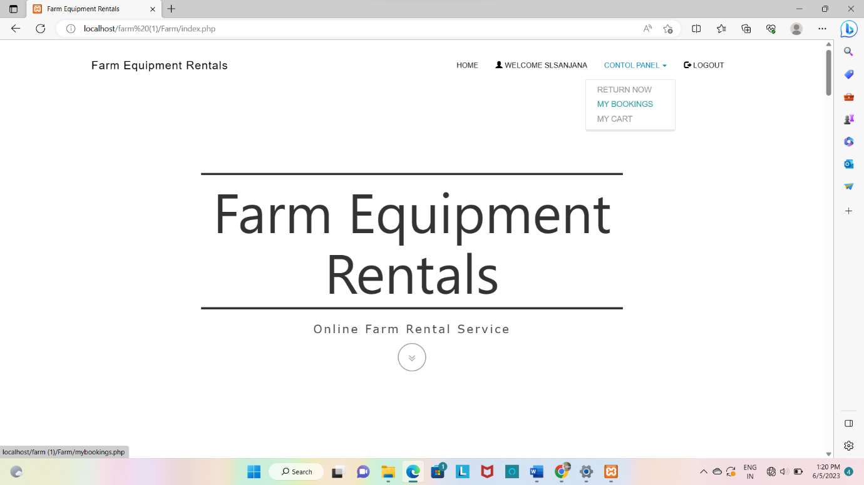

**Tools return page**

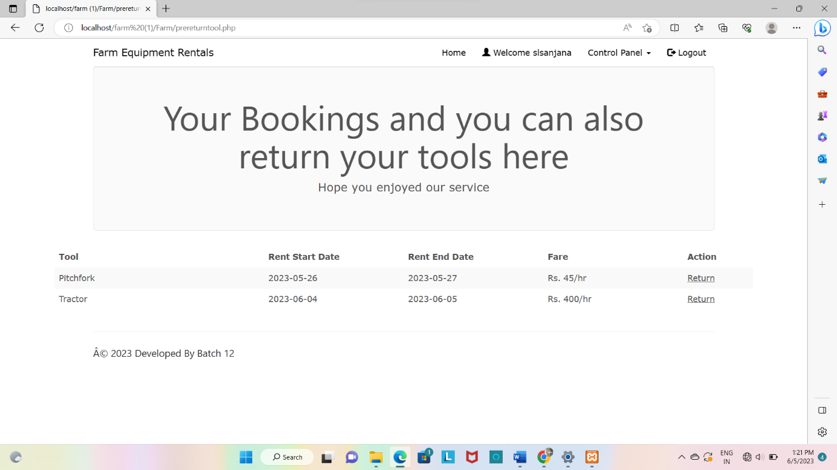

**8.1 RESULTS**

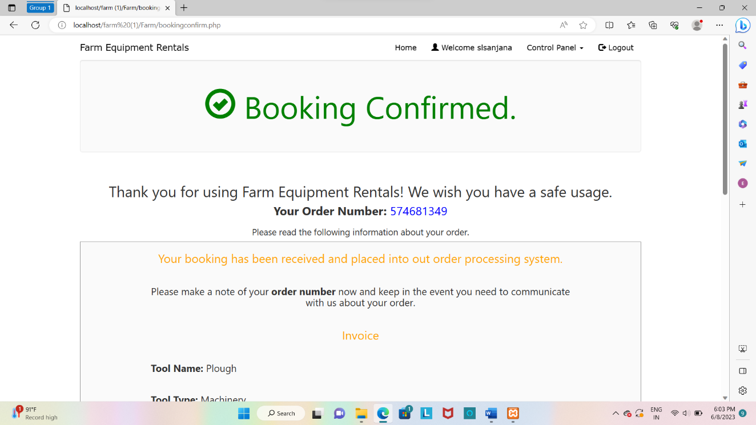

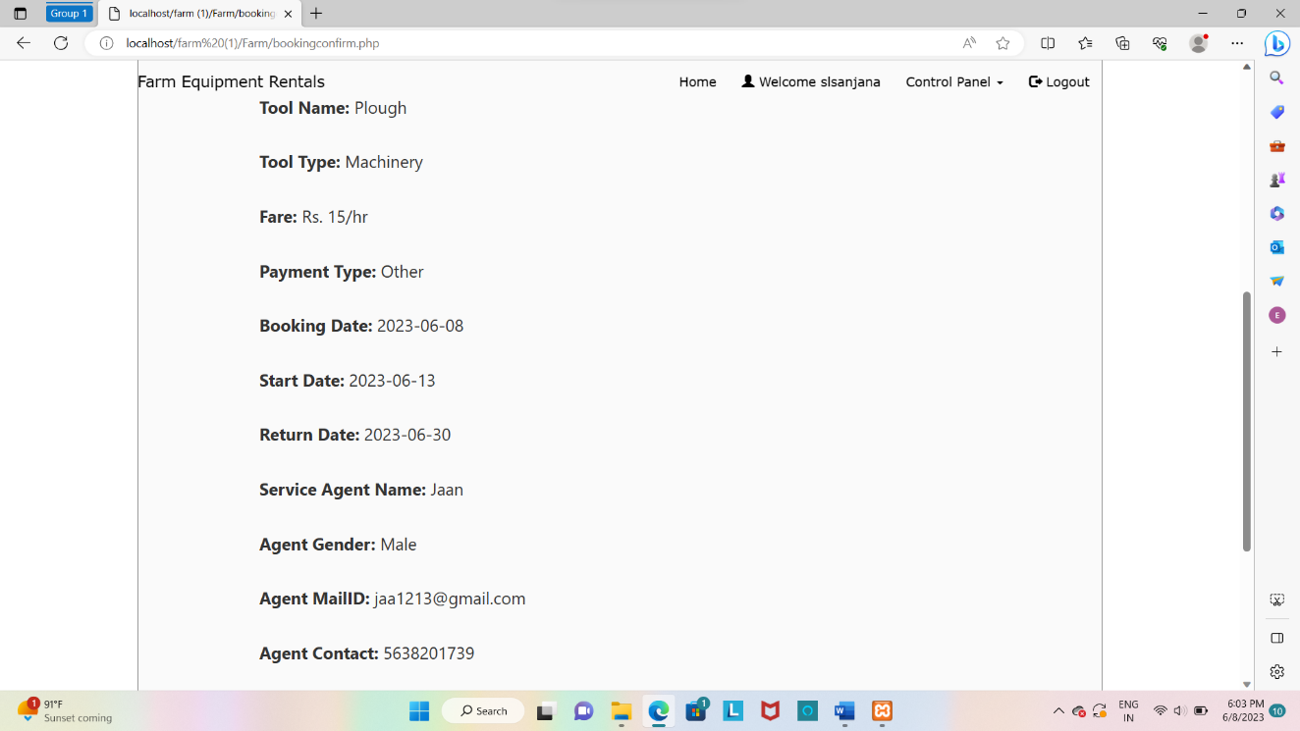

**CONCLUSION AND FUTURE SCOPE**

**9.Conclusion**

The system “Farm tool Outlet Management System ” is able to create to solve key problems of the farmers. The interface of the system in simple because farmers can access use full information regarding their farm tools, rates. Farmers can rent the tools at fair rates as they would find the current rates in the market on their phone itself. In this system farmers would find a good platform where they can rent different tools at single website . It is concluded that farmers can use the system efficiently with logging in, the system well proves to be an important bridge between customer who needs to rent tools and farmers who will sell tools for rent . In the future we will focus on improving this system by adding other features regarding their requirements of future customers.

**9.1 Future Scope**

We implemented this project by thinking about the farmers who want to sell their tools on rental basis and farmers who wants to rent these tools .This project also has numerous future applications as follows.

* We can provide more features like adding a video which shows how to use the tools in turn it also educates and encourages new farmers.
* We can also add features like buying the products permanent instead of renting it.

**BIBILIOGRAPY**

**10.Bibliography**

* PHP and MySQL Web Development – Luke Welling & Laura Thompson
* Head First PHP & MySQL – Lynn Beighley & Michael Morrison
* HTML and CSS: Design and build Websites – Jon Duckett

**10.1 Referred website**

* https://[www.geeksforgeeks.com](http://www.geeksforgeeks.com)/
* https://www.w3schools.com/

**ER DIAGRAM**

**CUSTOMERS**

MANAGES

**ORDERS**

ORDERS

**CATEGORY**

**ADMIN**

**MANAGES**

**FARM TOOLS**

ADDS